The pipe clip temperature sensors shown here are robust sensors that can be clipped directly onto copper pipes to measure the temperature of the liquids in the pipes. Each sensor contains a device called a thermistor. Thermistors are semiconductor devices that exhibit a temperature-dependent resistance described by:
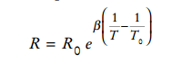

where R is the resistance (in Ω) at the temperature T (in °K), and R0 is the resistance (in Ω) at the temperature T0 (in °K). β is a constant that depends on the material used to make the thermistor. Thermistors are specified by providing values for R0, T0, and β. The thermistors used to make the pipe clip temperature sensors have R0 = 1075 Ω at T0 = 85 °C, and β = 3969 °K. (Notice that β has units of °K. Recall that the temperature in °K is obtained by adding 273 to the temperature in °C.) The liquid temperature, in °C, is determined from the resistance R, in Ω, using

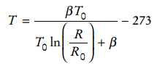

Write a C++ program that prompts the user for the thermistor resistance R and prints a message giving the liquid temperature in °C.

